Adobe Animate CC multiple choice with pictures

- A designer is creating a free-of-charge animation projection that other people can use as long as they give her credit for the work and don’t make any changes to it. Which Creative Common licenses indicates that an image can be used for free, requires that the original author is given credit, and the image must retain unchanged in the derivative work?
Please note the following acronyms:
CC0: Public Domain
BY: Attribution
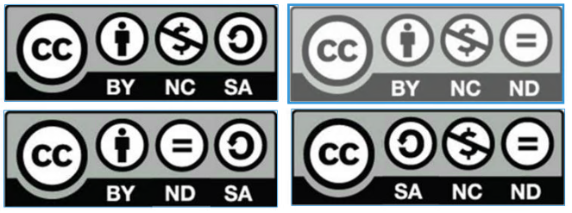

- Place the steps to dock the “Brush Library” next to the “Swatches” panel, and save the workspace as “Brushes” in the correct order. Drag the steps on the left to its correct position to the right.
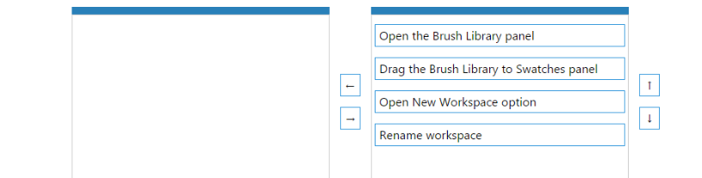

- Click on the image that portrays symmetrical balance.
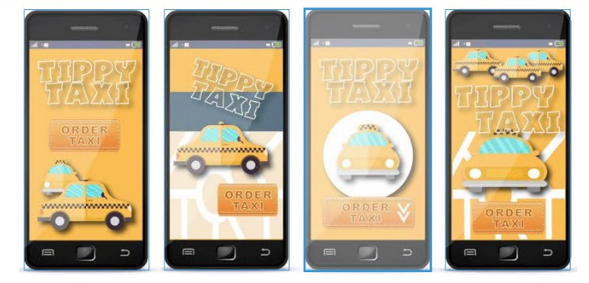

- Match each type of layer with its description. Answer options may be used more than once or not at all.
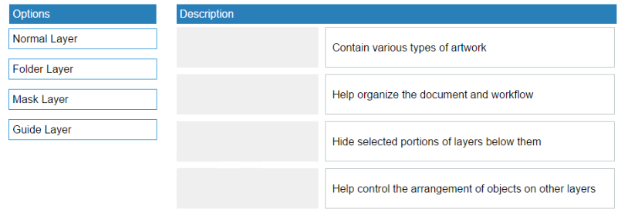

- Place the steps in the correct order for adding a sound from the Library to the Timeline and then adding an effect.
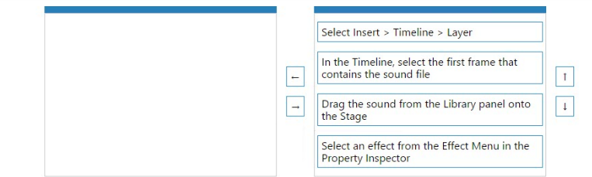

- Place the steps of the project management cycle in order.
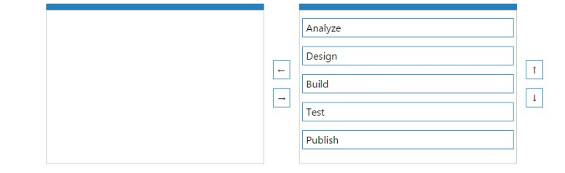
- Which image is an example of asymmetrical balance? (click on the correct image)
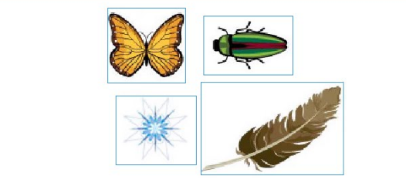

- An intern needs to review an Animate CC project that the supervisor feels may be completed. Place the steps in the correct sequence that the intern would follow to complete this assignment.
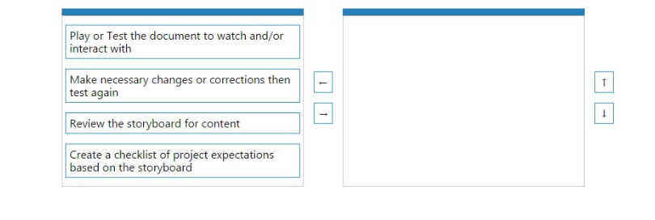
Response: 4, 3, 2, 1
- Click the button in the image that will create a new Symbol.
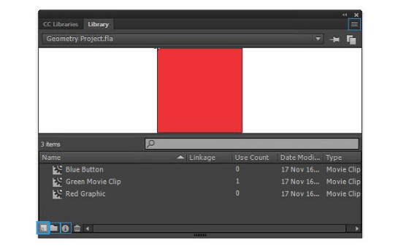

- Given the image:
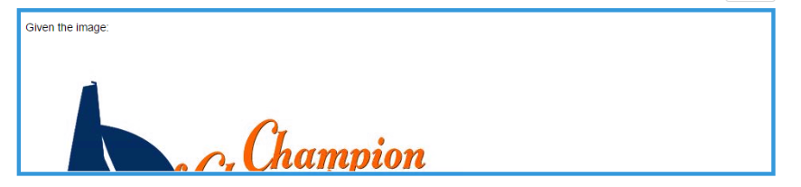
  - Split Complimentary
  - Analogous
  - Complimentary
  - Triad
- Match each ActionScript 3.0 Event Class with its description. Answer options may be used more than once or not at all.
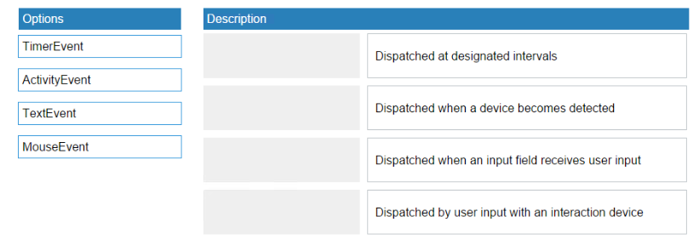

- Match each accessibility issue with the strategy used to address it. Answer options may be used more than once or not used at all.
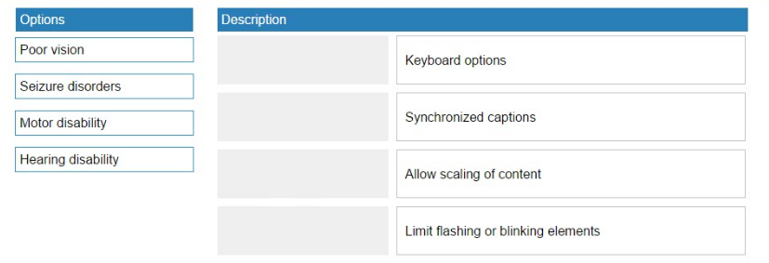
1 3, 2 4, 3 1, 4 2

- Click the Timeline button to turn off the visibility of robot’s eye in the attached image.
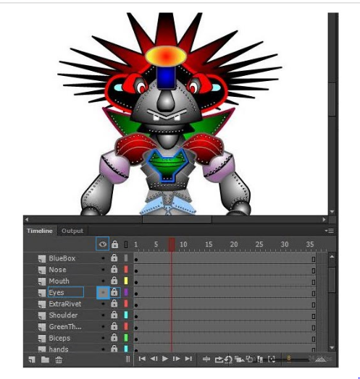

- Match each item to its corresponding highlighted code in the example. Answer options may be used more than once or not used at all.
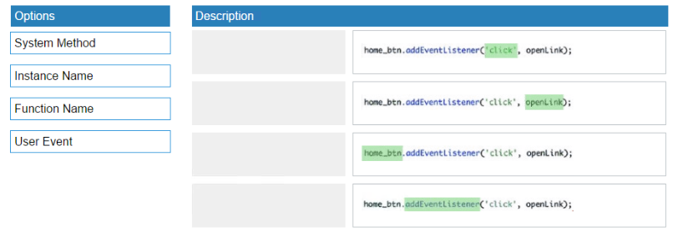
1 4, 2 3, 3 2, 4 1

